Native – Android

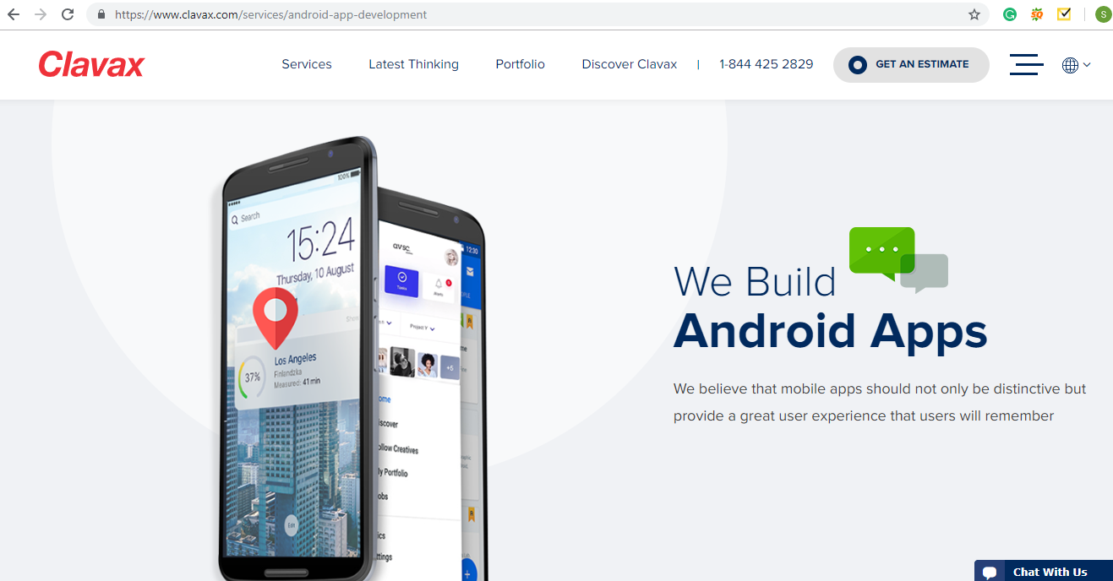

**Android Application**

We develop advanced and innovative android applications with great user experience to accomplish all your business needs.

Next>>

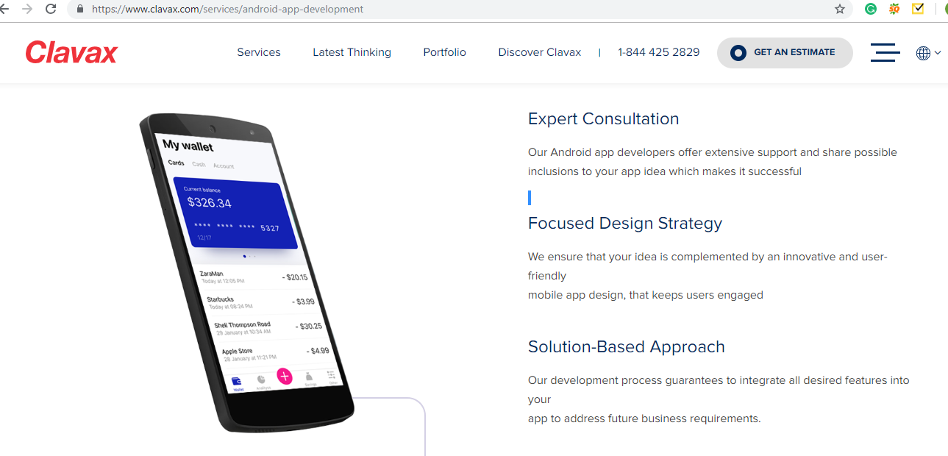

**Android App Approach**

Our strategy experts help in making an effective strategy for the growth of your mobile business.

**Android App Design and Development**

Our expert team will make a striking design and user experience. Our Android app developers ensure excellent output.

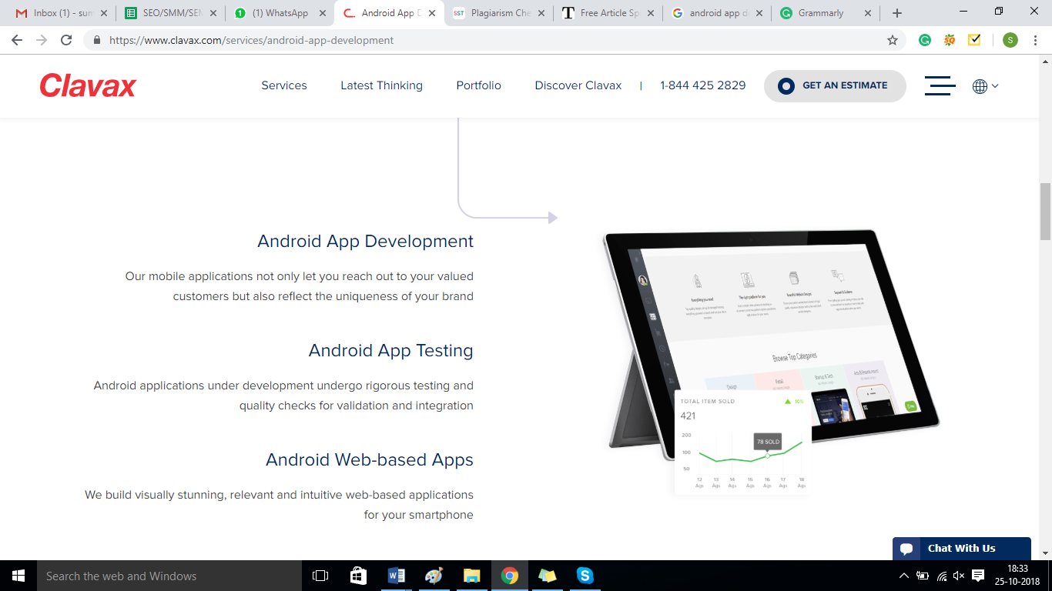

**Deliver:**

We value the time, hence never fail to deliver our quality product to our client on time. We include our client at every stage of development to have straightforwardness and least mistake. Therefore, we save our time as we lessen risk at the early stages of development.

Next>>

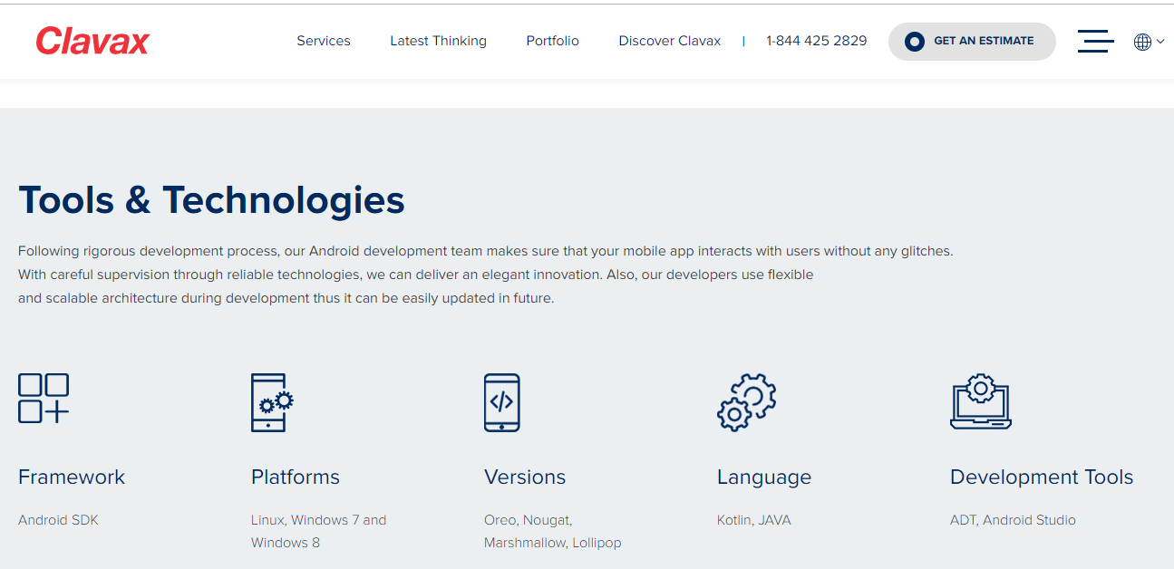

**Tools & Technologies**

Our Android development team ensures that your mobile application perform will without any glitches. With vigilant supervision through reliable technologies, we can deliver a well-designed innovation. We also ensure that our architecture is flexible and scalable so that it can be easily updated in future.

Next>>

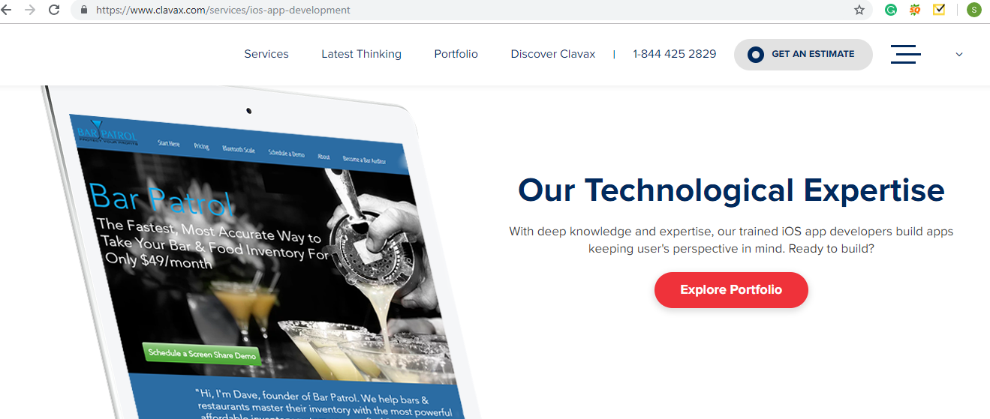

**Ready to Get Started?**

In the box use - Get Your Own Cavalry Today